ORIGINAL SURVEY  Q1 Tell us about needs, services and experiences for persons with developmental disabilities in Florida by completing this survey.  To be eligible to take this survey you be at least 18 years of age or older and the Caregiver or Family Member of a person with a developmental disability who lives in Florida.  If you are a self-advocate (person with a developmental disability) living in Florida and are 18 years of age or older please take the Self-Advocate Survey located at https://wellflorida.org/surveys/  Please respond to all surveys before April 15, 2020.  Send questions to fddc@fddc.org  End of Block: Introduction to Survey  Start of Block: Eligibility Block  Q41 Does the person with the developmental disability live in Florida?  - Yes (1)  - No (2)  Skip To: End of Block If Does the person with the developmental disability live in Florida? = No  Q46 In what county does the person with the developmental disability currently live?  ▼ Alachua County (1) ... I do not know (69)  Q42 What is your age?  - Less than 18 years old (1)  - 18 - 29 (2)  - 30 - 39 (3)  - 40 - 49 (4)  - 50 - 59 (5)  - 60 - 64 (6)  - 65 - 69 (7)  - 70 or older (8)  Skip To: End of Block If What is your age? = Less than 18 years old  End of Block: Eligibility Block  Start of Block: Demographics of Caregiver/Family Member  Q43 Select all categories that best describe your relationship to the person with the developmental disability.  - Parent (1)  - Grandparent (2)  - Brother/Sister (3)  - Legal Guardian Advocate or Legal Guardian (4)  - Other (7) ________________________________________________  Q58 Are you the primary caregiver for the person with the developmental disability? (A primary caregiver is responsible for the health, social, emotional and financial well-being of the person with a developmental disability.)  - Yes (4)  - No (5)  Q49 Do you live in Florida?  - Yes (1)  - No (2)  Skip To: Q48 If Do you live in Florida? = Yes  Skip To: Q51 If Do you live in Florida? = No  Q48 In what county do you live?  ▼ Alachua County (1) ... I do not know (69)  Q51 Which of these best describes you?  - White (1)  - African American or Black (2)  - Native American or Alaska Native (3)  - Asian (4)  - Pacific Islander or Native Hawaiian (5)  - Two or more races (6)  - Some other race (7)  - I prefer not to answer (8)  Q50 Are you Hispanic?  - Yes (1)  - No (2)  - I prefer not to answer (3)  Q59 Which of these best describes you?  - Female (1)  - Male (2)  - Transgender (3)  - I prefer not to answer (4)  - Not listed (please tell us) (5) ________________________________________________  End of Block: Demographics of Caregiver/Family Member  Start of Block: Demographics about the Person with a Developmental Disability  Q52 The next set of questions will be about the person with the developmental disability.  Q4 In what county does the person with a developmental disability currently live?  ▼ Alachua County (1) ... I do not know (69)  Q70 Where does the person with the developmental disability live?  - Group Home (1)  - Family Home (4)  - Intermediate Care Facility (ICF/DD) (5)  - His/Her own apartment/home (6)  - Assisted Living or Nursing Home (7)  - Homeless (8)  - Other (9) ________________________________________________  Q5 What is the age of the person with a developmental disability?  - Less than 5 years (9)  - 5 - 17 (10)  - 18 - 21 (1)  - 22 - 29 (2)  - 30 - 39 (3)  - 40 - 49 (4)  - 50 - 59 (5)  - 60 - 64 (6)  - 65 - 69 (7)  - 70 or older (8)  Q6 Which of these best describes the person with a developmental disability?  - White (1)  - African American or Black (2)  - Native American or Alaska Native (3)  - Asian (4)  - Pacific Islander or Native Hawaiian (5)  - Two or more races (6)  - Some other race (7)  - I prefer not to answer (8)  Q7 Is the person with a developmental disability Hispanic?  - Yes (1)  - No (2)  - I prefer not to answer (3)  Q8 Which of these best describes the person with the developmental disability?  - Female (1)  - Male (2)  - Transgender (3)  - I prefer not to answer (4)  - Not listed (please tell us) (5) ________________________________________________  End of Block: Demographics about the Person with a Developmental Disability  Start of Block: Services Utilized, Unmet Needs, Barriers  Q31 What services has the person with a developmental disability used in Florida in the past 2 years? (Select all that apply.)  - Abuse hotline, adult or child protective services (1)  - Employment opportunities and job training services (finding and keeping employment with or without supports) (2)  - Medical, mental health, dental health care, and wellness support services (3)  - Therapies (including physical, occupational, speech, and applied behavioral) (11)  - Education and school services including early identification and ongoing supports throughout schooling (4)  - Housing services (help finding and keeping safe, affordable living arrangements) (5)  - Community support services (for example, respite care, companion services, getting and using assistive technology, counseling services, personal care assistance, faith-based and help with expenses) (6)  - Child care services (before school, afterschool programs, summer camps, and early care services) (7)  - Recreational opportunities and services in his/her community (8)  - Transportation services (9)  - ⊗The person with a developmental disability has not used any of these services (10)  Q34 In the past two (2) years in what areas did the person with a developmental disability not have their needs met? (Select all areas that apply.)  - Abuse hotline, adult or child protective services (1)  - Employment opportunities and job training services (finding and keeping employment with or without supports) (2)  - Medical, mental health, dental health care, and wellness support services (3)  - Therapies (including physical, occupational, speech, and applied behavioral) (12)  - Education and school services including early identification and ongoing supports throughout schooling (4)  - Housing services (help finding and keeping safe, affordable living arrangements) (5)  - Community support services (for example, respite care, companion services, getting and using assistive technology, counseling services, personal care assistance, faith-based and help with expenses) (6)  - Child care services (before school, afterschool programs, summer camps, and early care services) (7)  - Recreational opportunities and services in his/her community (8)  - Transportation services (9)  - Other (10) ________________________________________________  - ⊗The person with a developmental disability did not have unmet needs in the past 2 years (11)  Display This Question: If In the past two (2) years in what areas did the person with a developmental disability not have Abuse hotline, adult or child protective services  Q36 Why was their need for abuse hotline, adult or child protective services not met? (Select all reasons.)  - Did not know who to call (1)  - Report not accepted (13)  - Incident determined unfounded (2)  - Other (please tell us) (12) ________________________________________________  Display This Question: If In the past two (2) years in what areas did the person with a developmental disability not have Employment opportunities and job training services (finding and keeping employment with or without supports)  Q60 Why was their need for employment opportunities and job training services not met? (Select all reasons.)  - Cost (1)  - Waiting list (2)  - Accessibility (3)  - Transportation (4)  - No providers in the area (5)  - Eligible for service but no appointments available (8)  - Location of service (9)  - Service times (cannot go when service times are offered) (10)  - Was not eligible for the service (11)  - Other (please tell us) (12) ________________________________________________  Display This Question: If In the past two (2) years in what areas did the person with a developmental disability not have Medical, mental health, dental health care, and wellness support services  Q61 Why was their need for medical, mental health, dental health care, and wellness support services not met? (Select all reasons)  - Cost (1)  - Waiting list (2)  - Accessibility (3)  - Transportation (4)  - No providers in the area (5)  - Eligible for service but no appointments available (8)  - Location of service (9)  - Service times (cannot go when service times are offered) (10)  - Was not eligible for the service (11)  - Other (please tell us) (12) ________________________________________________  Display This Question: If In the past two (2) years in what areas did the person with a developmental disability not have Therapies (including physical, occupational, speech, and applied behavioral)  Q71 Why was their need for therapies (including physical, occupational, speech, applied behavioral) services not met? (Select all reasons)  - Cost (1)  - Waiting list (2)  - Accessibility (3)  - Transportation (4)  - No providers in the area (5)  - Eligible for service but no appointments available (8)  - Location of service (9)  - Service times (cannot go when service times are offered) (10)  - Was not eligible for the service (11)  - Other (please tell us) (12) ________________________________________________  Display This Question: If In the past two (2) years in what areas did the person with a developmental disability not have Education and school services including early identification and ongoing supports throughout schooling  Q62 Why was their need for education and school services including early identification and ongoing supports throughout schooling not met? (Select all reasons.)  - Cost (1)  - Waiting list (2)  - Accessibility (3)  - Transportation (4)  - No providers in the area (5)  - Eligible for service but no appointments available (8)  - Location of service (9)  - Service times (cannot go when service times are offered) (10)  - Was not eligible for the service (11)  - Other (please tell us) (12) ________________________________________________  Display This Question: If In the past two (2) years in what areas did the person with a developmental disability not have = Housing services (help finding and keeping safe, affordable living arrangements)  Q63 Why was their need for housing services not met? (Select all reasons.)  - Cost (1)  - Waiting list (2)  - Accessibility (3)  - Transportation (4)  - No housing service providers in the area (5)  - No housing in the area (6)  - Eligible for service but no appointments available (8)  - Location of service (9)  - Service times (cannot go when service times are offered) (10)  - Was not eligible for the service (11)  - Other (please tell us) (12) ________________________________________________  Display This Question: If In the past two (2) years in what areas did the person with a developmental disability not have Community support services (for example, respite care, companion services, getting and using assistive technology, counseling services, personal care assistance, faith-based and help with expenses)  Q64 Why was their need for community support services not met? (Select all reasons)  - Cost (1)  - Waiting list (2)  - Accessibility (3)  - Transportation (4)  - No providers in the area (5)  - No community support services in the area (6)  - Eligible for service but no appointments available (8)  - Location of service (9)  - Service times (cannot go when service times are offered) (10)  - Was not eligible for the service (11)  - Other (please tell us) (12) ________________________________________________  Display This Question: If In the past two (2) years in what areas did the person with a developmental disability not have Child care services (before school, afterschool programs, summer camps, and early care services)  Q65 Why was their need for child care (before school, afterschool programs, summer camps, and early care) services not met? (Select all reasons)  - Cost (1)  - Waiting list (2)  - Accessibility (3)  - Transportation (4)  - No providers in the area (5)  - Eligible for service but no spots available for my child (8)  - Location of service (9)  - Service times (cannot go when service times are offered) (10)  - Was not eligible for the service (11)  - Other (please tell us) (12) ________________________________________________  Display This Question: If In the past two (2) years in what areas did the person with a developmental disability not have = Recreational opportunities and services in his/her community  Q66 Why was their need for recreational opportunities and services in his/her community not met? (Select all reasons)  - Cost (1)  - Waiting list (2)  - Accessibility (3)  - Transportation (4)  - No providers in the area (5)  - No recreation opportunities in the area (7)  - Eligible for service but no appointments available (8)  - Location of service (9)  - Service times (cannot go when service times are offered) (10)  - Was not eligible for the service (11)  - Other (please tell us) (12) ________________________________________________  Display This Question: If In the past two (2) years in what areas did the person with a developmental disability not have = Transportation services  Q67 Why was their need for transportation services not met? (Select all reasons.)  - Cost (1)  - Waiting list (2)  - Accessibility (3)  - No transportation service providers in the area (5)  - Eligible for service but no appointments available (8)  - Location of service (9)  - Service times (cannot go when service times are offered) (10)  - Was not eligible for the service (11)  - Other (please tell us) (12) ________________________________________________  Display This Question: If In the past two (2) years in what areas did the person with a developmental disability not have = Other  Q68 Why were their needs for other services not met? (Select all reasons)  - Cost (1)  - Waiting list (2)  - Accessibility (3)  - Transportation (4)  - No providers in the area (5)  - Eligible for service but no appointments available (8)  - Location of service (9)  - Service times (cannot go when service times are offered) (10)  - Was not eligible for the service (11)  - Other (please tell us) (12) ________________________________________________  Q54 What are the top three (3) most important service areas for the person with a developmental disability in your care? (Select three.)  - Abuse hotline, adult or child protective services (1)  - Employment opportunities and job training services (finding and keeping employment with or without supports) (2)  - Medical, mental health, dental health care, and wellness support services (3)  - Therapies (including physical, occupational, speech, and applied behavioral) (12)  - Education and school services including early identification and ongoing supports throughout schooling (4)  - Housing services (help finding and keeping safe, affordable living arrangements) (5)  - Community support services (for example, respite care, companion services, getting and using assistive technology, counseling services, personal care assistance, fathi-based and help with expenses) (6)  - Child care services (before school, afterschool programs, summer camps, and early care services) (7)  - Recreational opportunities and services in his/her community (8)  - Transportation services (9)  - Other (10) ________________________________________________  Q38 What services do you believe the person with a developmental disability will need in the next year (12 months)? (Select all that apply.)  - Abuse hotline, adult or child protective services (1)  - Employment opportunities and job training services (finding and keeping employment with or without supports) (2)  - Medical, mental health, dental health care, and wellness support services (3)  - Therapies (including physical, occupational, speech, and applied behavioral) (11)  - Education and school services including early identification and ongoing supports throughout schooling (4)  - Housing services (help finding and keeping safe, affordable living arrangements) (5)  - Community support services (for example, respite care, companion services, getting and using assistive technology, counseling services, personal care assistance, fathi-based and help with expenses) (6)  - Child care services (before school, afterschool programs, summer camps, and early care services) (7)  - Recreational opportunities and services in the community (8)  - Transportation services (9)  - ⊗No services will be needed (10)  Q56 What are the three (3) top services or resources you need as a caregiver to be able to best assist the person with the developmental disability? (Select three.)  - Support for an aging caregiver (4)  - Meeting other families of persons with developmental disabilities (5)  - Before and after school care, summer camp (6)  - Respite care (7)  - Assistance with daily caregiving tasks (8)  - Local community-based services (9)  - Assistance with meeting the healthcare needs of persons with developmental disabilities (10)  - Estate planning (11)  - Early intervention services (12)  - Advocacy and leadership training and opportunities (15)  - Safe and secure housing (16)  - Getting or using transportation services (17)  - Assistance with school to adult life transitioning (18)  - Qualified providers (19)  - I do not need any resources (20)  - Other (please tell us) (21) ________________________________________________  Q72 What information do you need as a caregiver to be able to best assist the person with the developmental disability? (Select the top three most important information needs)  - Information on guardianship options and alternatives (1)  - Information on caregiver rights and responsibilities (2)  - Information on how to get services (3)  - Finding support for an aging caregiver (4)  - Information on school services (13)  - Information on benefits and social security eligibility including Medicaid Waiver programs (14)  - Information on transportation services (17)  - Information about school to adult life transitioning (18)  - I do not need any information (20)  - Other (please tell us) (21) ________________________________________________  Display This Question: If Are you the primary caregiver for the person with the developmental disability? (A primary caregiver = Yes)  Q69 What are three (3) critical issues you face as the primary caregiver of a person with development disabilities? (Select three issues)  - Fatigue, stress and/or burnout (1)  - Financial issues (2)  - Personal safety (4)  - Social isolation (5)  - Worry about the future (6)  - Physical health problems (for example, heart disease, back pain, headaches) (7)  - Mental health-related problems (for example, depression, alcohol or substance misuse) (8)  - Employment-related issues (9)  - Managing other family responsibilities (10)  - Lack of time to pursue own interests (12)  - Interpersonal relationship/intimate relationship issues (11)  - Other (please tell us) (13) ________________________________________________ | 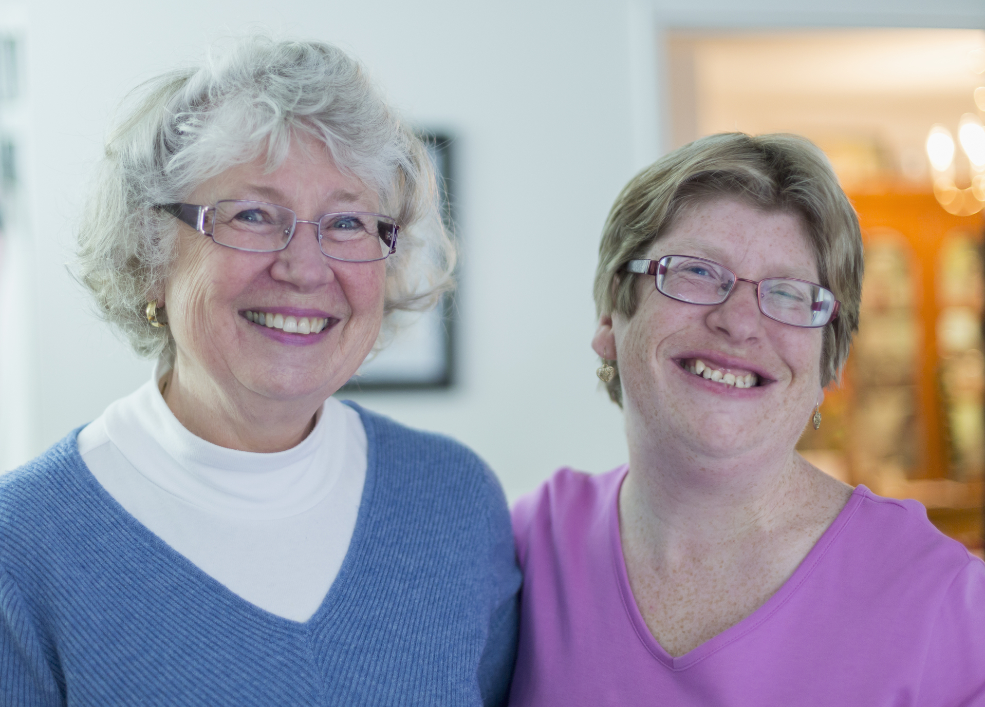  EASY READ SURVEY  Q1 Tell us about the person with a disability you care for. We want to make sure their needs are being met.  These questions are for you only if:  - You care for a person with a  developmental disability who lives in Florida.  - You are at least 18 years old.  If you are a person with a developmental disability, please take the Self-Advocate Survey located at: https://wellflorida.org/surveys  Please finish this form by XXXXX, 2020.  Send questions to fddc@fddc.org  Q41 Does the person you care for you live in Florida?  - Yes (1)  - No (2)  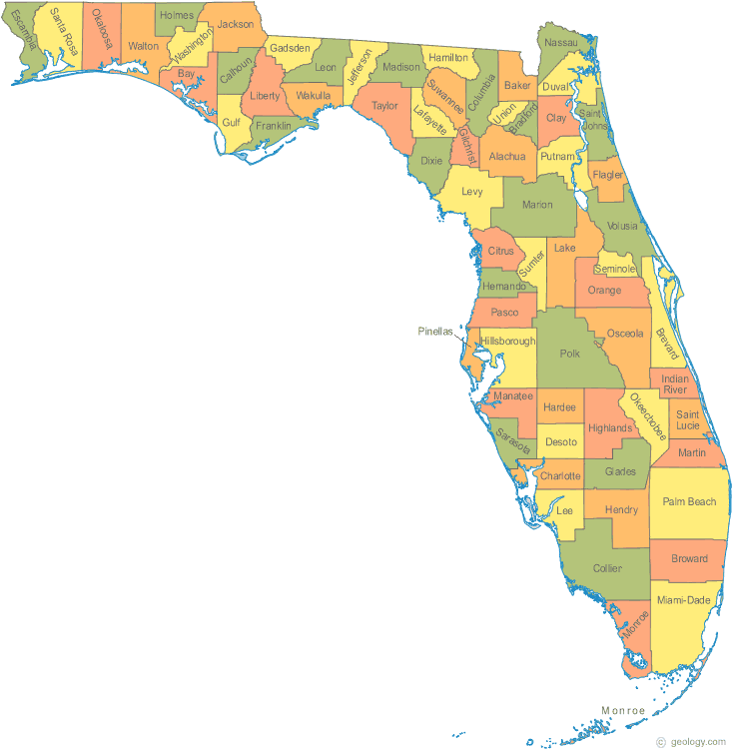  Q46 Which county does the person you care for you live in?  ▼ Alachua County (1) ... I do not know (69)  INCLUDE COUNTY MAP OF FL  Q42 How old are YOU?  (We will ask later about the person you care for.)  - Younger than 18 (1)  - 18 – 29 (2)  - 30 – 39 (3)  - 40 – 49 (4)  - 50 – 59 (5)  - 60 – 64 (6)  - 65 – 69 (7)  - 70 or older (8)  Q43. What is your relationship to the person you care for?  - I am a parent (1)  - I am a grandparent (2)  - I am a brother or sister (3)  - I am a legal guardian or advocate (11)  - Something else (4)  Q58 Are you the main person in charge* for the person with the developmental disability? *responsible for the health, social, emotional, and financial well-being  - Yes (4)  - No (5)  Q49 Do YOU live in Florida?  (We will ask later about the person you care for.)  - Yes (1)  - No (2)  Q48 Which county do YOU live in?  INCLUDE FL COUNTY MAP  ▼ Alachua County (1) ... I do not know (69)  Q51 Which describes YOU?  (We will ask later about the person you care for.)  - White (1)  - African American or Black (2)  - Native American or Alaska Native (3)  - Asian (4)  - Pacific Islander or Native Hawaiian (5)  - Two or more races (6)  - Some other race (7)  - I do not want to answer (8)  Q50 Are YOU Hispanic?  (We will ask later about the person you care for.)  - Yes (1)  - No (2)  - I do not want to answer (3)  Q59 Which describes YOU?  (We will ask later about the person you care for.)  - Female (1)  - Male (2)  - Transgender (3)  - I do not want to answer (4)  - Not listed (please tell us) (5)  FIELD FOR COMMENTS  Q52 The next set of questions will be about the person you are completing this for.  Q4 Which county does the person you care for live in?  ▼ Alachua County (1) ... I do not know (69)  Q70 Where does the person you are completing this for live?  - A group home (1)  - With their family (2)  - An Intermediate Care Facility* (ICF) (3)  * A building where they live and learn things with many other people who have disabilities and have someone available 24 hours  - Their own apartment or house (4)  - Assisted living or a nursing home (5)  - They are homeless (6)  - Other (7)  FIELD FOR COMMENTS  Q5 How old is the person you are completing this for?  - Younger than 5 (9)  - 5 - 17 (10)  - 18 – 21 (1)  - 22 – 29 (2)  - 30 – 39 (3)  - 40 – 49 (4)  - 50 – 59 (5)  - 60 – 64 (6)  - 65 – 69 (7)  - 70 or older (8)  Q6 Which describes the person you are completing this for?  - White (1)  - African American or Black (2)  - Native American or Alaska Native (3)  - Asian (4)  - Pacific Islander or Native Hawaiian (5)  - Two or more races (6)  - Some other race (7)  - I do not want to answer (8)  Q7 Is the person you are completing this for Hispanic?  - Yes (1)  - No (2)  - I do not want to answer (3)  Q8 Which describes the person you care for?  - Female (1)  - Male (2)  - Transgender (3)  - I do not want to answer (4)  - Not listed (please tell us) (5)  FIELD FOR COMMENTS  Q31 What services has the person you care for used in the last 2 years? (Check all that apply.)  - Abuse hotline or protective services (1)  - Finding a job or job training and help (2)  - Medical, mental health, dental, or wellness (3)  - Physical, occupational, speech, or behavioral therapy (11)  - School (4)  - Housing services or help with home life (5)  - Support services like counseling, technology help, or money help (6)  - Childcare (7)  - Recreation (8)  - Getting rides or using a bus (9)  - ⊗They have not used any of these services (10)  Q34 In the past 2 years, what services was the person you care for unable to get?  (Check all that apply.)  - Abuse hotline or protective services (1)  - Finding a job or job training and help (2)  - Medical, mental health, dental, or wellness (3)  - Physical, occupational, speech, or behavioral therapy (11)  - School (4)  - Housing services or help with living arrangements (5)  - Supports like counseling, technology help, or money help (6)  - Childcare (7)  - Recreation in the community (8)  - Getting rides or using a bus (9)  - ⊗She/he has not had any unmet needs (10)  Q36 Why was their need for abuse hotline or protective services not met?  (Check all that apply.)  - We did not know who to call (1)  - Our report was not accepted (13)  - The problem we reported was not proven (2)  - Other (please tell us) (12)  FIELD FOR COMMENTS  Q60 Why was their need for finding a job or job training and help not met?  (Check all that apply.)  - Cost (1)  - Waiting list (2)  - Accessibility (3)  - Could not get a ride (4)  - No one in their area (5)  - No appointments available (8)  - Too hard to get there (9)  - They cannot go when times are offered (10)  - They are not eligible (11)  - Other (please tell us) (12)  FIELD FOR COMMENTS  Q61 Why was their need for medical, mental health, dental, or wellness services not met?  (Check all that apply.)  - Cost (1)  - Waiting list (2)  - Accessibility (3)  - Could not get a ride (4)  - No one in their area (5)  - No appointments available (8)  - Too hard to get there (9)  - They cannot go when times are offered (10)  - They are not eligible (11)  - Other (please tell us) (12)  FIELD FOR COMMENTS  Q71 Why was their need for physical, occupational, speech, or behavioral therapy not met?  (Check all that apply.)  - Cost (1)  - Waiting list (2)  - Accessibility (3)  - Could not get a ride (4)  - No one in their area (5)  - No appointments available (8)  - Too hard to get there (9)  - They cannot go when times are offered (10)  - They are not eligible (11)  - Other (please tell us) (12)  FIELD FOR COMMENTS  Q62 Why was their need for school services not met?  (Check all that apply.)  - Cost (1)  - Waiting list (2)  - Accessibility (3)  - Could not get a ride (4)  - No one in their area (5)  - No appointments available (8)  - Too hard to get there (9)  - They cannot go when times are offered (10)  - They are not eligible (11)  - Other (please tell us) (12)  FIELD FOR COMMENTS  Q63 Why was their need for housing services or help with living arrangements not met?  (Check all that apply.)  - Cost (1)  - Waiting list (2)  - Accessibility (3)  - Could not get a ride (4)  - No one in their area (5)  - No housing available (6)  - No appointments available (8)  - Too hard to get there (9)  - They cannot go when times are offered (10)  - They are not eligible (11)  - Other (please tell us) (12)  FIELD FOR COMMENTS  Q64 Why was their need for support services like counseling, technology help, or money help not met?  (Check all that apply.)  - Cost (1)  - Waiting list (2)  - Accessibility (3)  - Could not get a ride (4)  - No providers in their area (5)  - No services in their area (5)  - No appointments available (8)  - Too hard to get there (9)  - They cannot go when times are offered (10)  - They are not eligible (11)  - Other (please tell us) (12)  FIELD FOR COMMENTS  Q65 Why was their need for childcare not met?  (Check all that apply.)  - Cost (1)  - Waiting list (2)  - Accessibility (3)  - Could not get a ride (4)  - No one in their area (5)  - No spots available (8)  - Too hard to get there (9)  - They cannot go when times are offered (10)  - They are not eligible (11)  - Other (please tell us) (12)  FIELD FOR COMMENTS  Q66 Why was their need for recreation or community services not met?  (Check all that apply.)  - Cost (1)  - Waiting list (2)  - Accessibility (3)  - Could not get a ride (4)  - No one in their area (5)  - No activities available (7)  - No appointments available (8)  - Too hard to get there (9)  - They cannot go when times are offered (10)  - They are not eligible (11)  - Other (please tell us) (12)  FIELD FOR COMMENTS  Q67 Why was their need for transportation services not met?  (Check all that apply.)  - Cost (1)  - Waiting list (2)  - Accessibility (3)  - No one in their area (5)  - No appointments available (8)  - Too hard to get there (9)  - They cannot go when times are offered (10)  - They are not eligible (11)  - Other (please tell us) (12)  FIELD FOR COMMENTS  Q68 Why was their need for other services not met?  (Check all that apply.)  - Cost (1)  - Waiting list (2)  - Accessibility (3)  - Could not get a ride (4)  - No one in their area (5)  - No appointments available (8)  - Too hard to get there (9)  - They cannot go when times are offered (10)  - They are not eligible (11)  - Other (please tell us) (12)  FIELD FOR COMMENTS  Q54 What are the 3 most important services for the person you care for? (Check 3.)  - Abuse hotline or protective services (1)  - Finding a job or job training and help (2)  - Medical, mental health, dental, or wellness (3)  - Physical, occupational, speech, or behavioral therapy (12)  - School (4)  - Housing services or help with living arrangements (5)  - Supports like counseling, technology help, or money help (6)  - Childcare (7)  - Recreation or help in the community (8)  - Getting rides or using a bus (9)  - Other (10)  FIELD FOR COMMENTS  Q38 What services will the person you care for need in the next year? (Check all that apply.)  - Abuse hotline or protective services (1)  - Finding a job or job training and help (2)  - Medical, mental health, dental, or wellness (3)  - Physical, occupational, speech, or behavioral therapy (12)  - School (4)  - Housing services or help with living arrangements (5)  - Supports like counseling, technology help, or money help (6)  - Childcare (7)  - Recreation or help in the community (8)  - Getting rides or using a bus (9)  - None (10)  Q56 What are the 3 most important things you need to help you provide care? (Check 3.)  - Help as you get older (4)  - Getting together with other people who care for someone with a disability (5)  - Childcare and summer camp (6)  - Someone to give you breaks from caregiving (7)  - Help with daily caregiving (8)  - Services close to home (9)  - Healthcare for the person you care for (10)  - Money planning (11)  - Early intervention (planning before problems arise) (12)  - Leadership opportunities (15)  - Safe housing (16)  - Getting rides (17)  - Help with school-to-adult transition (18)  - Finding good service providers (19)  - I do not need any help (20)  - Other (please tell us) (21)  FIELD FOR COMMENTS  Q72 What information would be most helpful to you in caring for a person with a developmental disability?  (Check 3.)  - Guardianship (1)  - Caregiver rights (2)  - How to get services (3)  - Support as you age (4)  - School (13)  - Benefits, Social Security, and Medicaid (14)  - Transportation (17)  - School-to-adult transition (18)  - I do not need any information (20)  - Other (please tell us) (21)  FIELD FOR COMMENTS  Q69 What are 3 most serious problems you face as the primary caregiver of a person with a developmental disability?  (Check 3.)  - Tiredness or stress (1)  - Money worries (2)  - Personal safety (4)  - Loneliness (5)  - Worry about the future (6)  - Physical health problems (like heart disease, back pain, or headaches) (7)  - Mental health problems (like depression or alcohol abuse) (8)  - Job problems (9)  - Keeping up with other family responsibilities (10)  - No time for myself (12)  - Problems with my relationships (11)  - Other (please tell us) (13)  FIELD FOR COMMENTS

